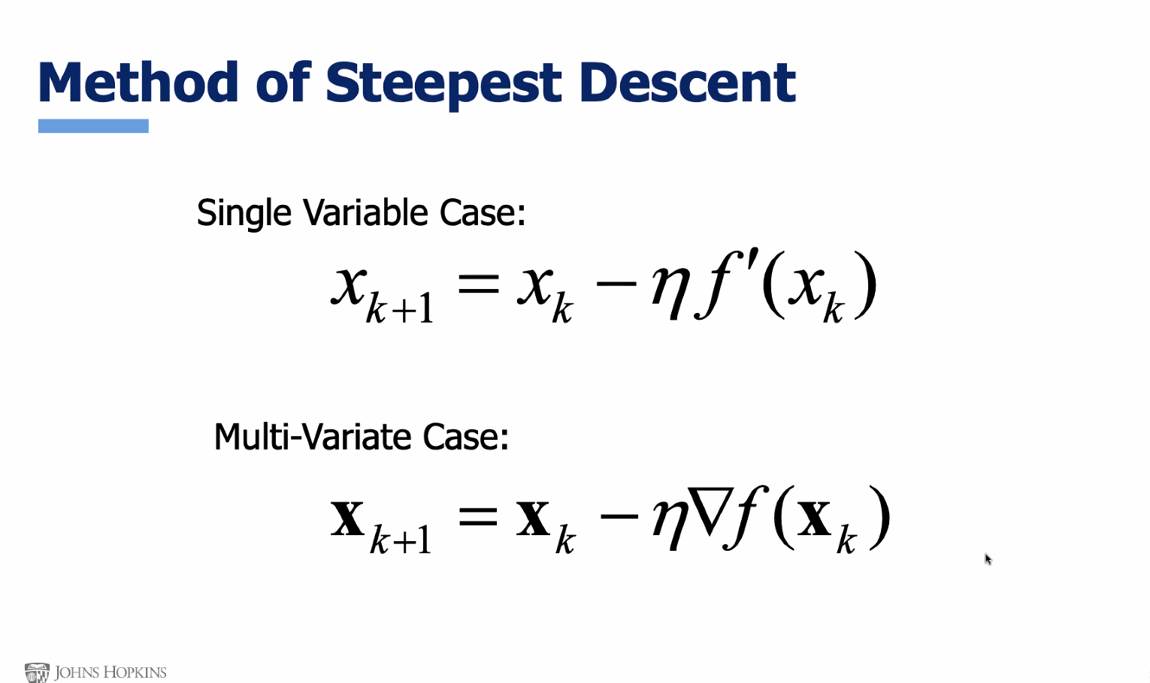
VECTORS IN BOLD

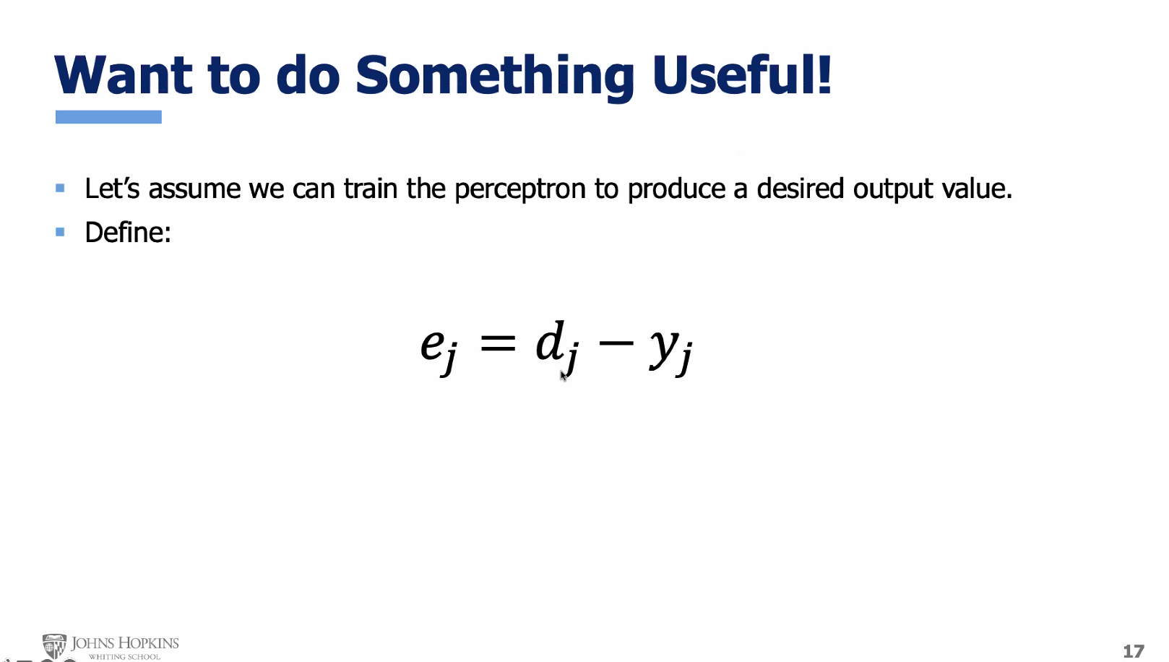
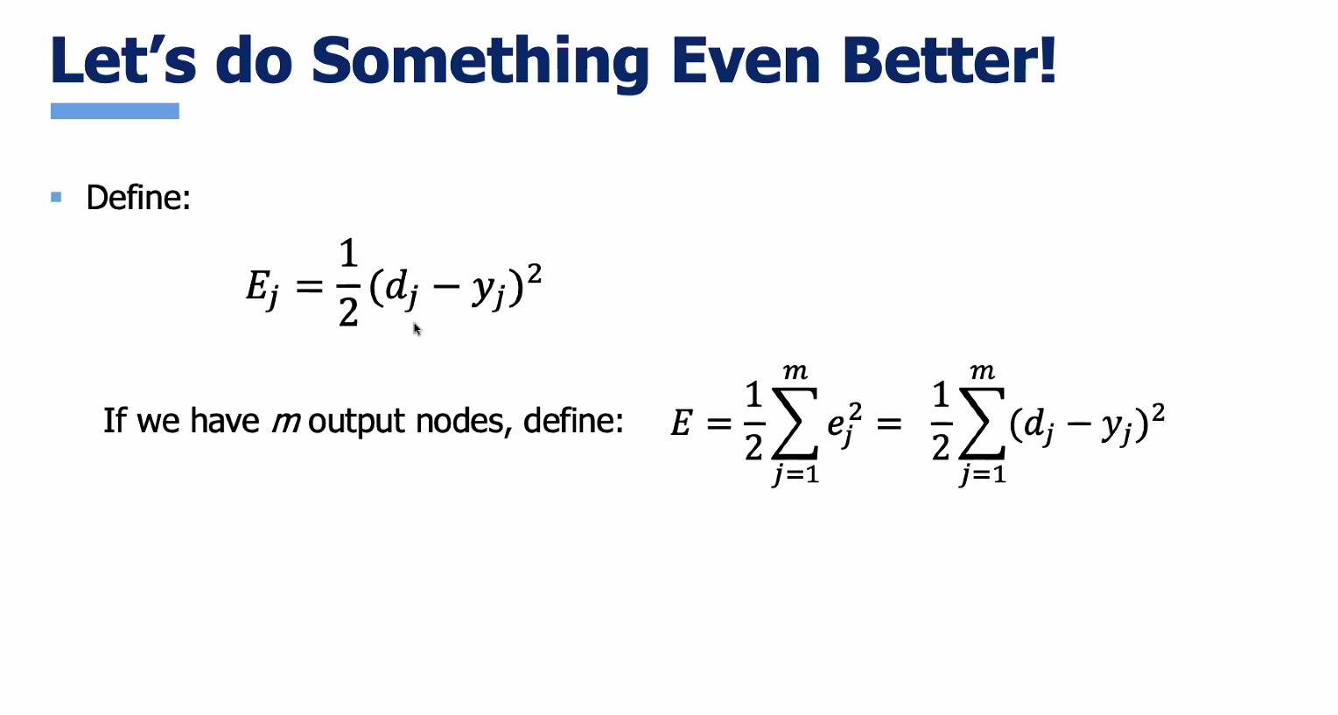
MINIMUM VALUE NOW 0, AND CAN NEVER BE NEGATIVE

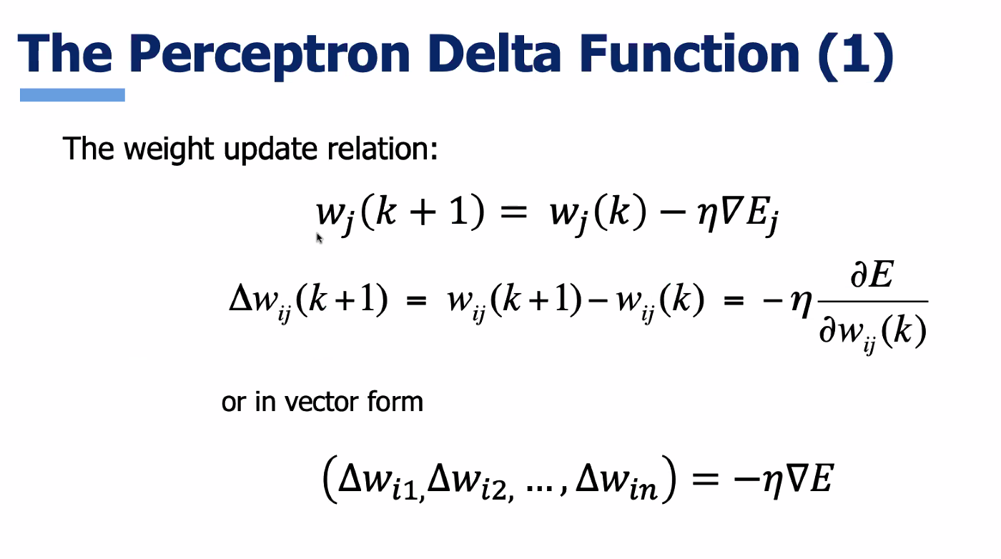

ARGUMENT IS THE WEIGHTS NOT THE INPUTS

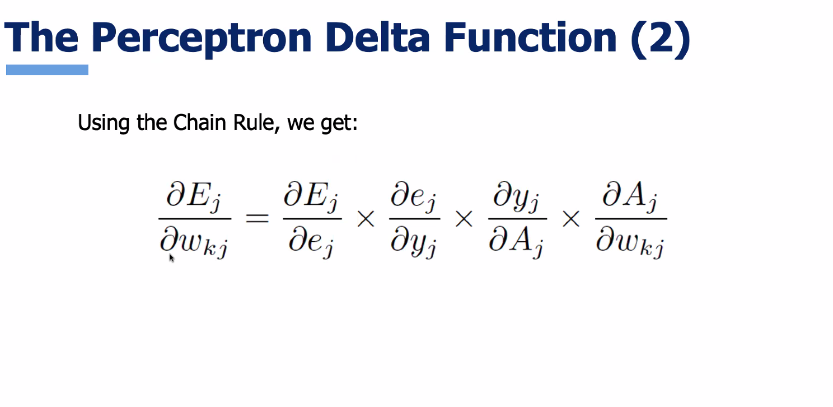
PARTIAL D4ERIVAT5IVE OF ERROR WITH RESPECT TO WEIGHTS SO WE CAN ADJUST WEIGHTS

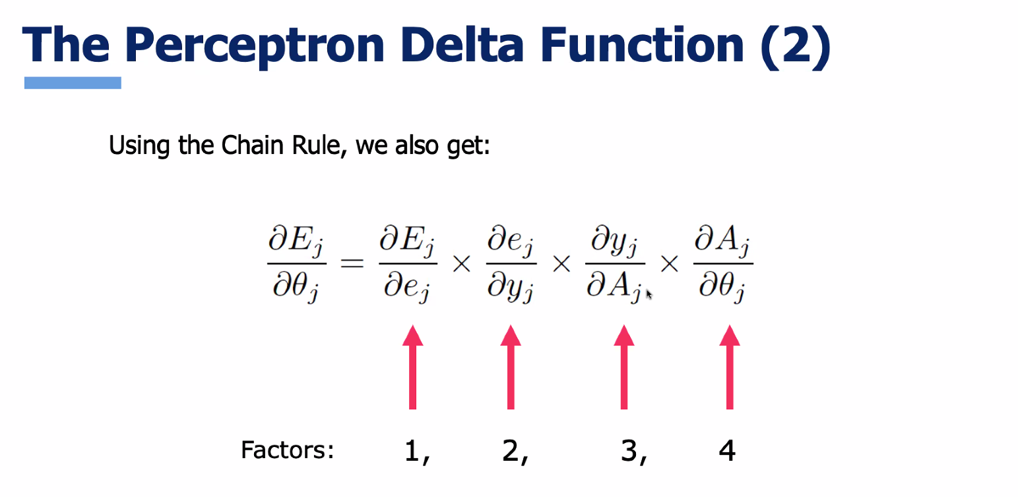

JUST CHANGED THE FOURTH FACTOR TO GET DERIVATIVE FOR BIAS

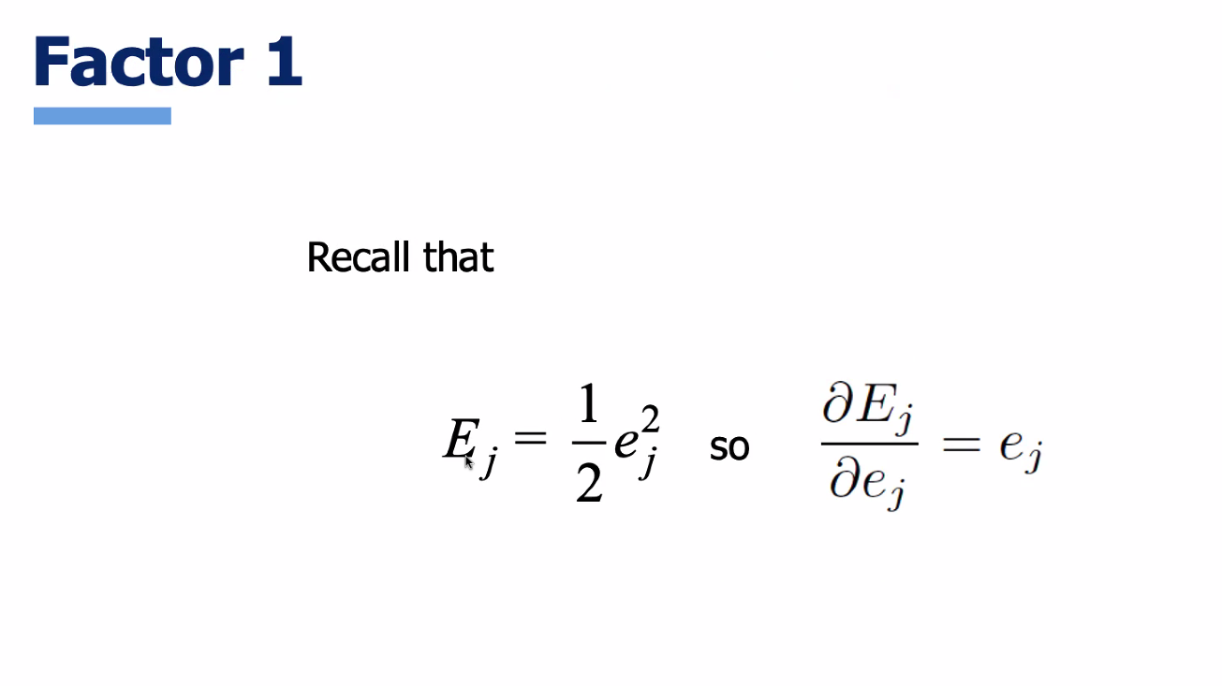

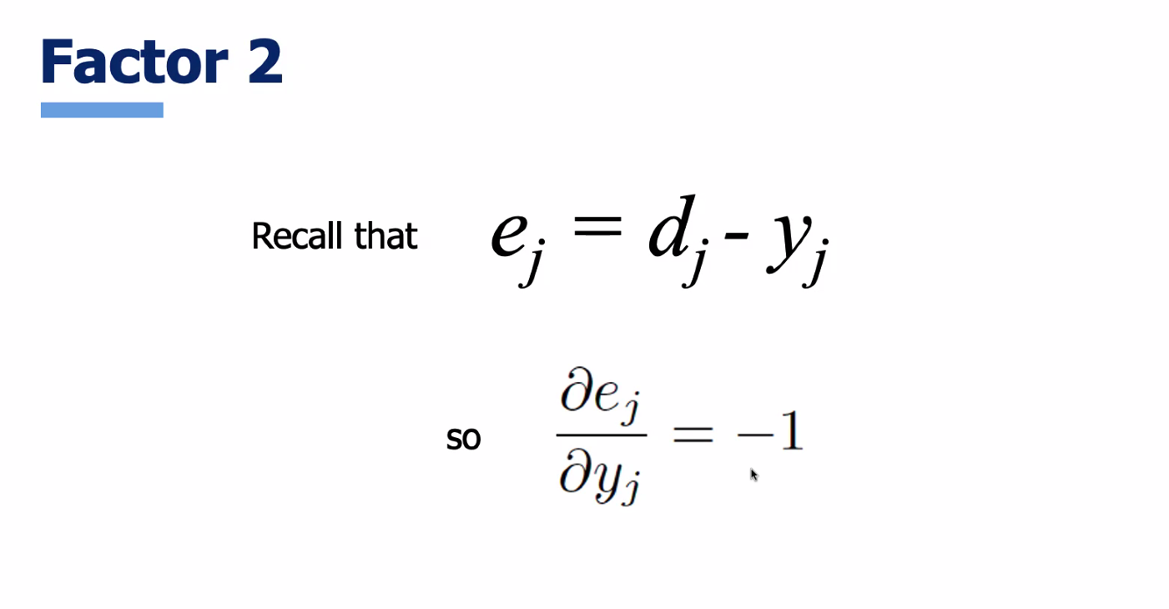

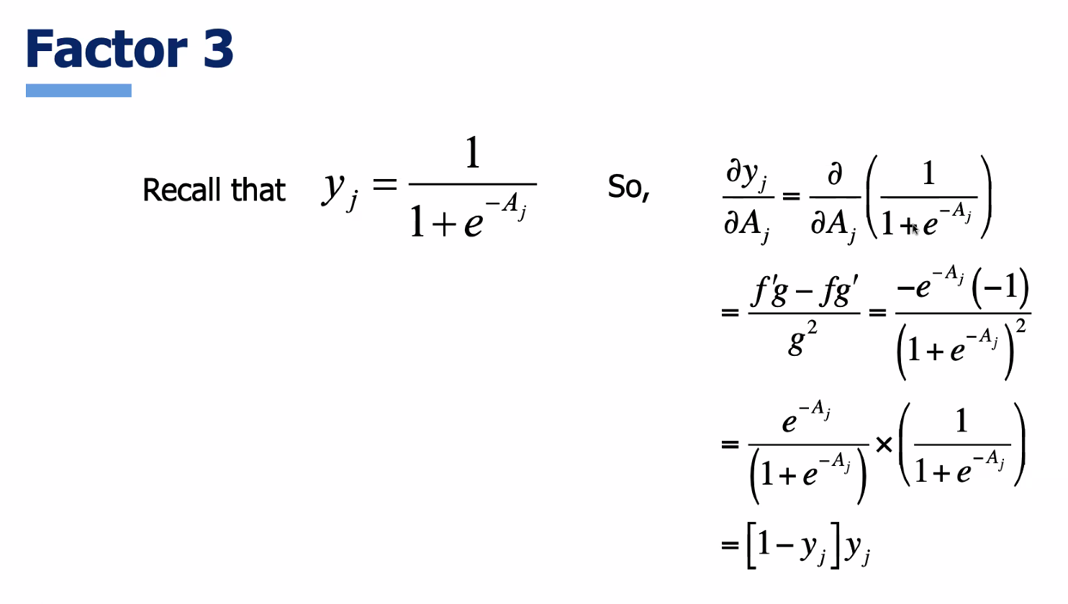

WEIGHT FROM INPUT K
ALL CONSTANTS EXCEPT WHEN i IS K
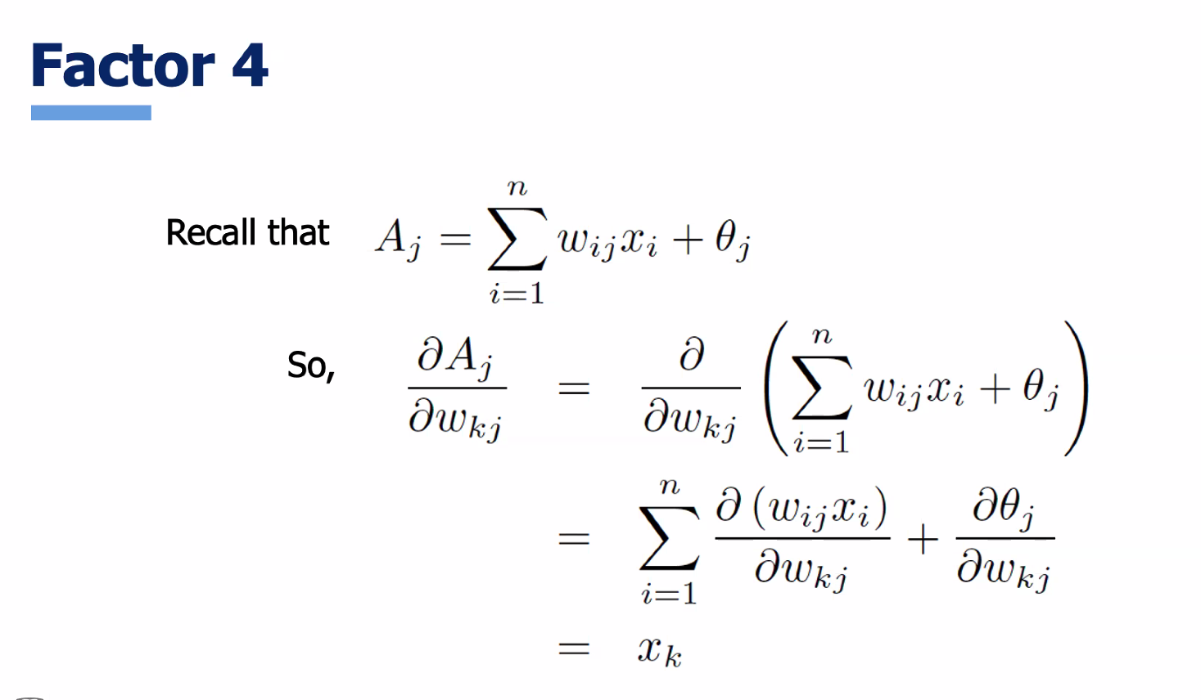
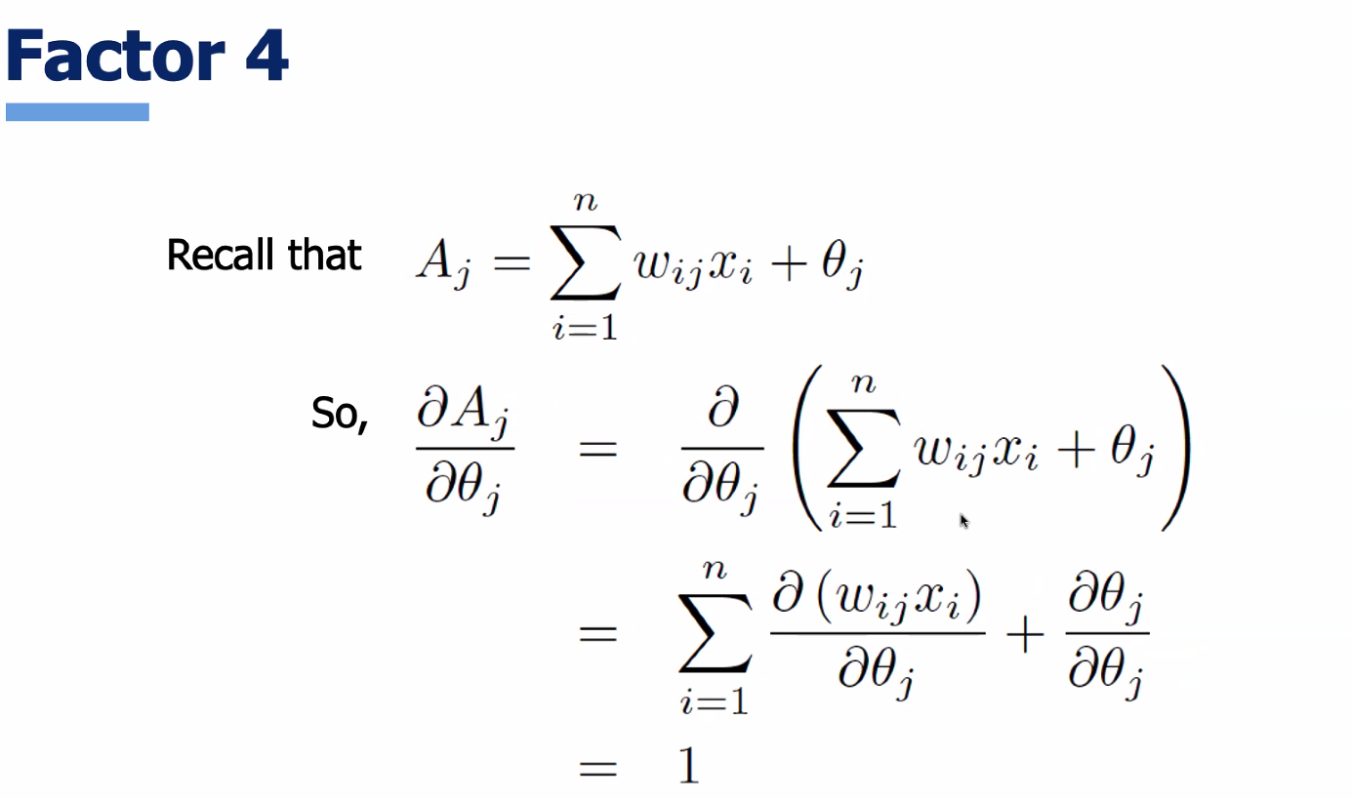

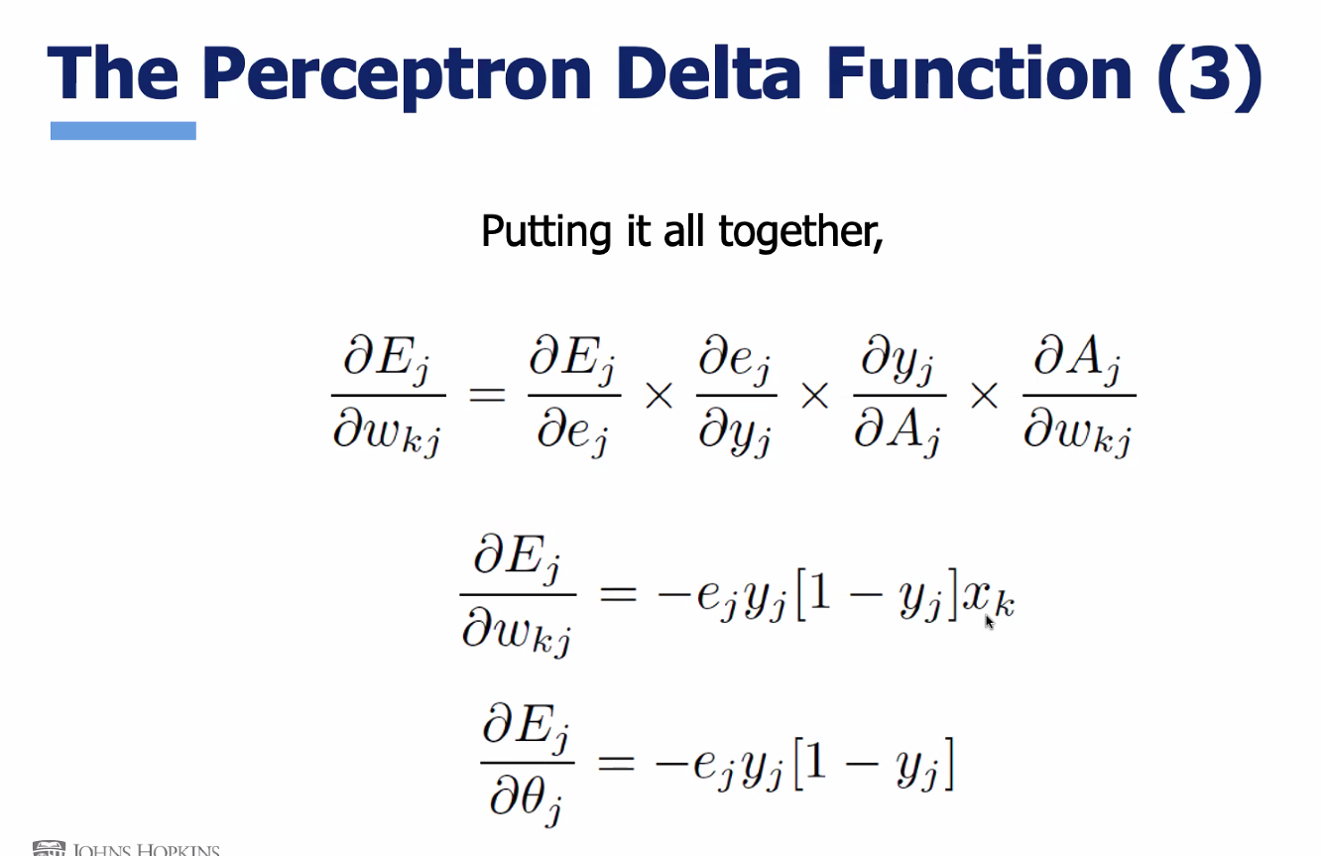
These are the gradient values

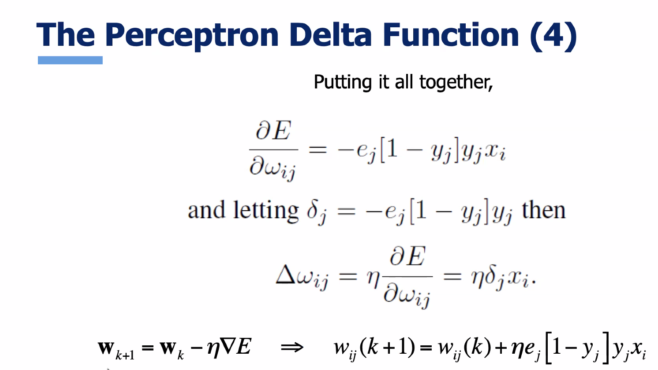

The last output there is the perceptron delta function ( this is the delta function for the sigmoid function)

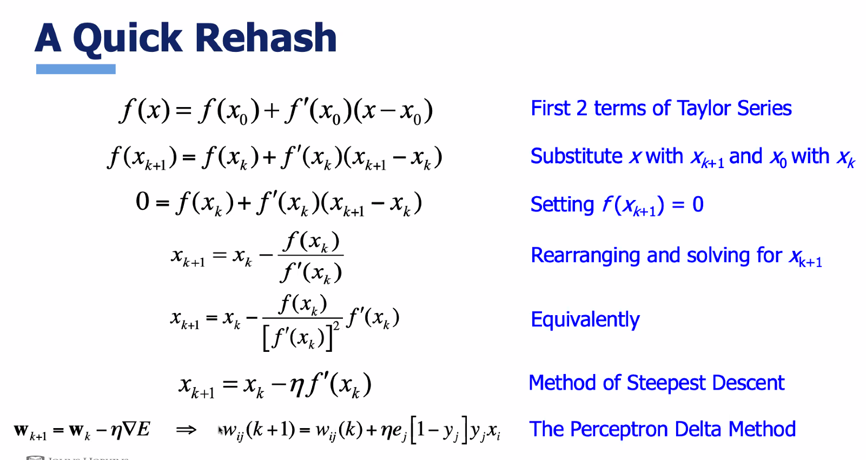

For the sigmoid activation function

Derivative of softmax is the derivative of sigmoid times (d-y) desired minus output:P
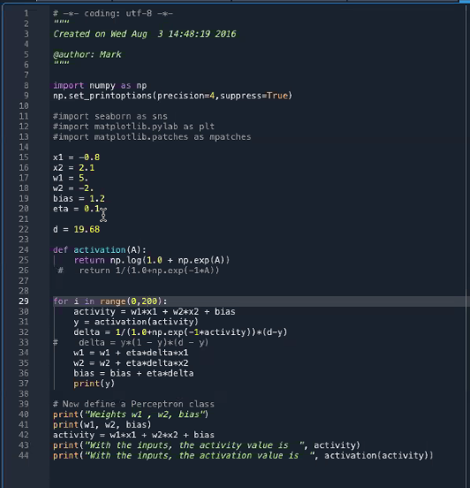
script for method of steepest decent
Training a perceptron is
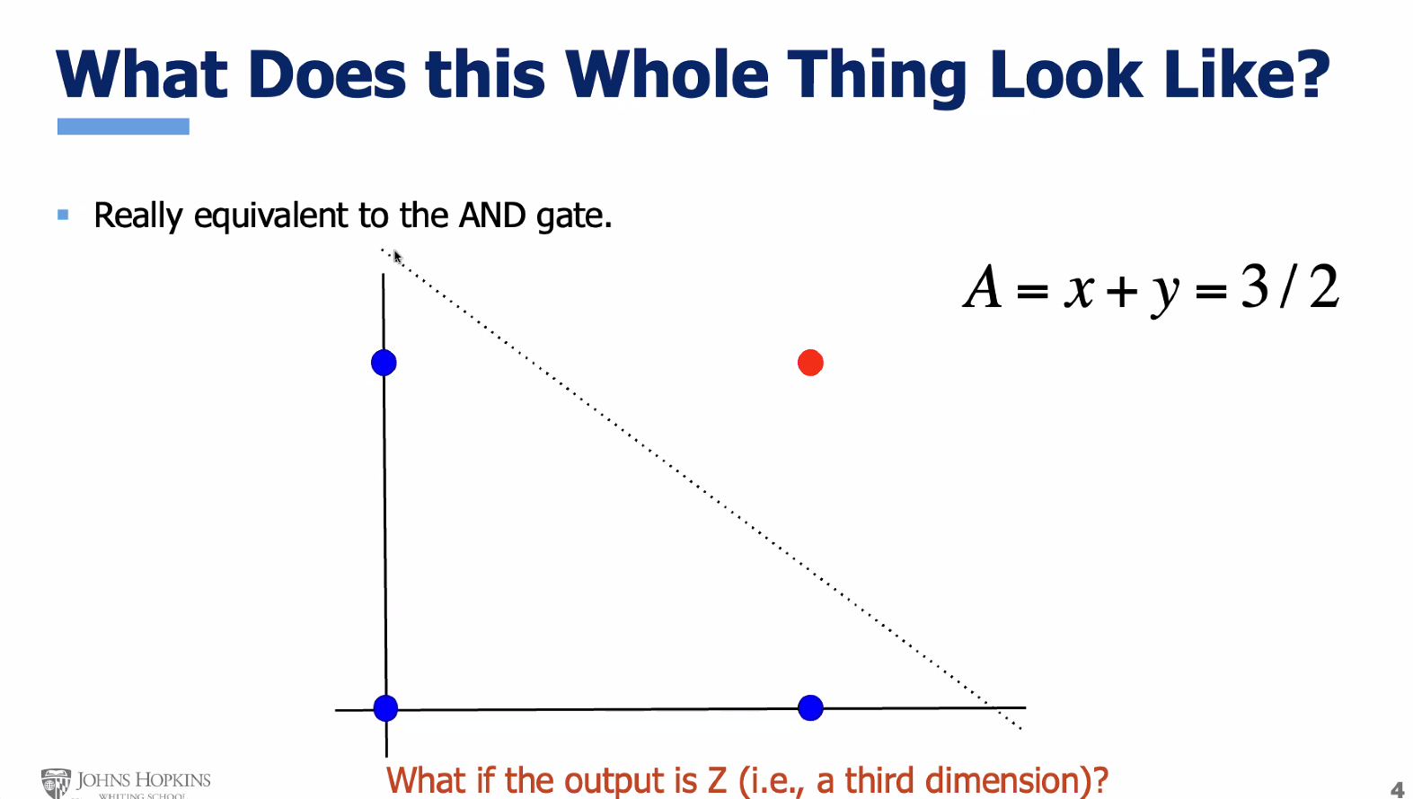

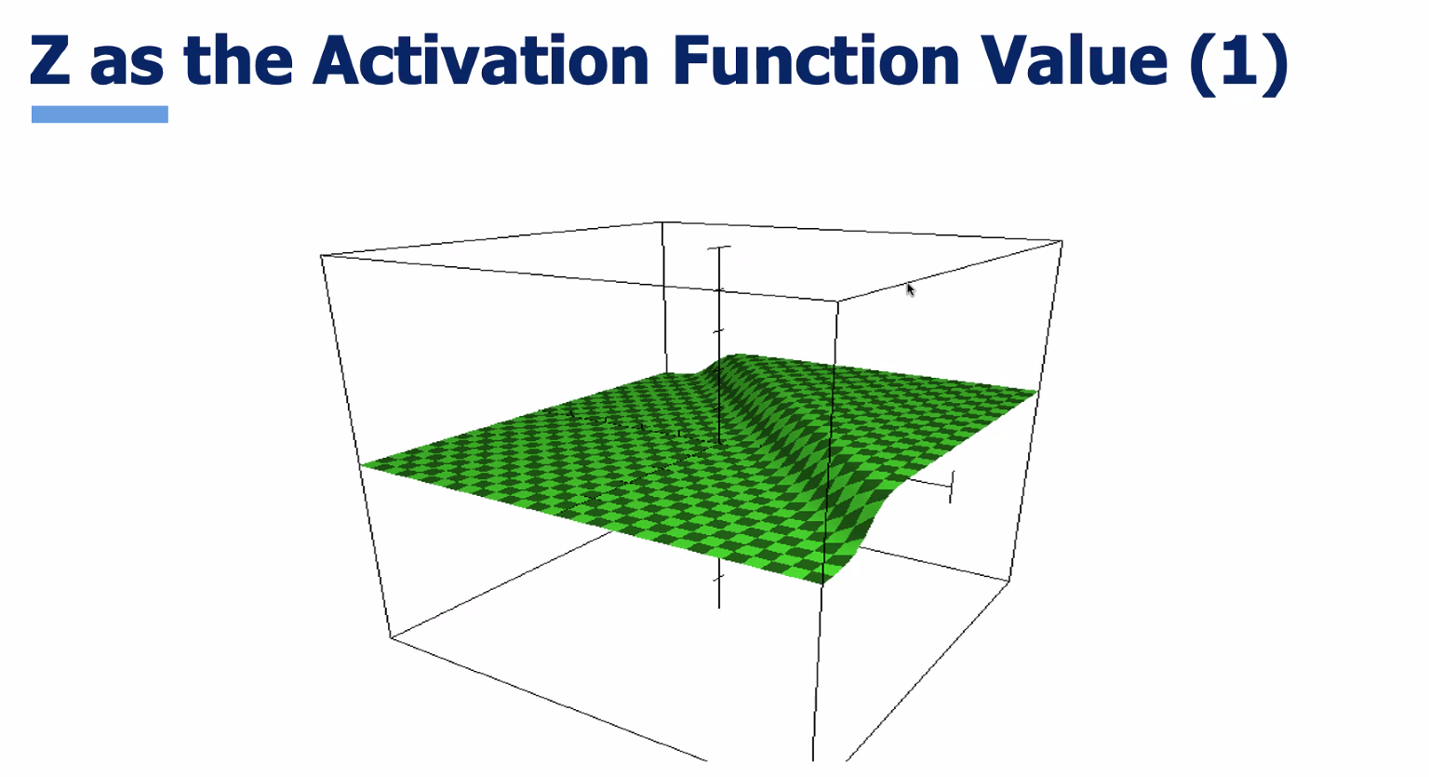sigmoid in three dimensions
For every x1 and x2 you get a z on that surface

What about separating these points?:
